**Project Initialization and Planning Phase**

| Date | 9 July 2024 |
| --- | --- |
| Team ID | SWTID1720019244 |
| Project Name | Traffictelligence: Advanced Traffic Volume Estimation with Machine Learning |
| Maximum Marks | 3 Marks |

**Define Problem Statements (Customer Problem Statement Template):**

**TrafficTelligence is an advanced system that uses machine learning algorithms to estimate and predict traffic volume with precision. By analyzing historical traffic data, weather patterns, events, and other relevant factors, TrafficTelligence provides accurate forecasts and insights to enhance traffic management, urban planning, and commuter experiences.**

Reference: https://miro.com/templates/customer-problem-statement/

**Example:**

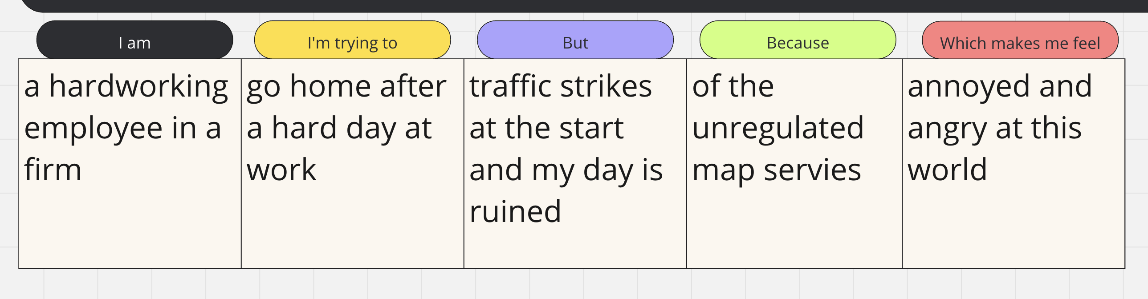

|  |  |  |  |  |  |
| --- | --- | --- | --- | --- | --- |
| **Problem**  **Statement (PS)** | **I am**  **(Customer)** | **I’m trying to** | **But** | **Because** | **Which makes me feel** |
| PS-1 | An employee at a firm | Go home after a hard day at work | Traffic strikes | Of the unregulated map services | Annoyed and angry at this world |